The purpose of this document is to describe the RockBLOCK, and how to access the account. The account for the RockBLOCK will be needed in order to set an end destination for messages, as well as purchasing credits and a monthly line rental.

**Important Information:** The RockBLOCK is **STATIC SENSITIVE** meaning **it can be damaged by static**. Try your best to discharge any static on you before handling the RockBLOCK. Also, there is a patch antenna on the bottom of the RockBLOCK that you should be weary of. Be careful not to damage it. The antenna can be seen in the picture below.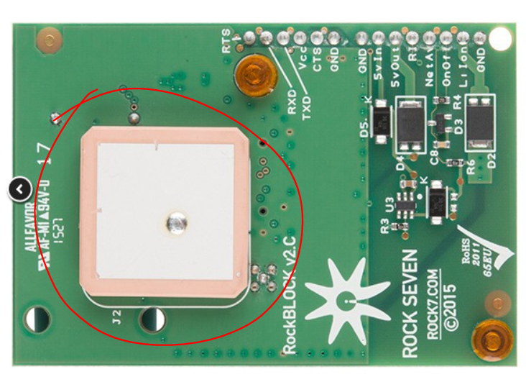

**Purpose:**

The purpose of the RockBLOCK is to take the sensor data from the Arduino Uno and send it via satellite to an ending destination (see “Block Diagram” document in the project folder). Right now, the RockBLOCK is set up to send to an email address. It is important to note that it is possible to be set up for HTTP posting as well, however email is the simplest of the two options.

**Pinout:**

It would be ideal to analyze how the RockBLOCK is wired to the Arduino before you disconnect anything. As of right now, it is being powered by the 5V supply on the bread board. **Please still read the pinout information before starting.** To find the pinout information for the RockBLOCK, see page 2 of the “Rough Pinout Schematic” document in the project folder. This document will talk about the upper and lower headers, and what pins are used for what. There is also plenty of documentation online for this.

**Account Access and Explanation:**

You can access the website for the RockBLOCK by using the link below. You should arrive at a webpage, prompting you for a username and password as seen in the picture below the link. The username and password can be found just below the picture.

URL: <https://rockblock.rock7.com/Operations>

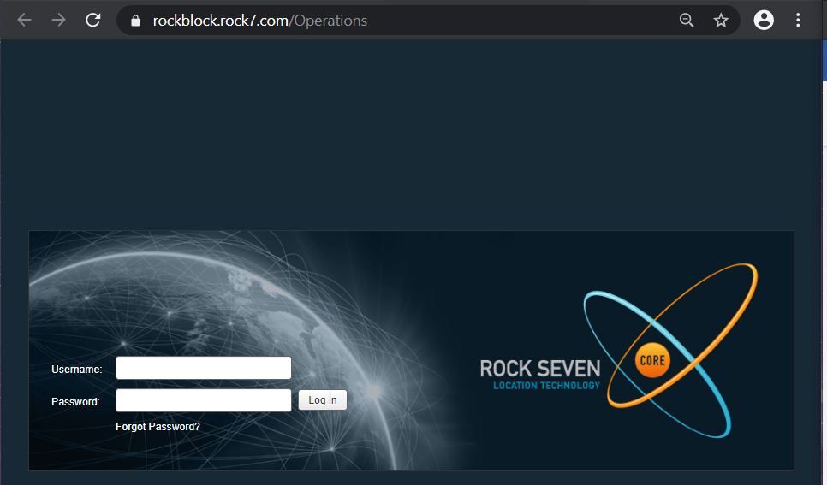

**Username:** [bhill@mtech.edu](mailto:bhill@mtech.edu)

**Password:** TechDigger2020

Once the username and password are entered in properly, you will arrive at the “My RockBLOCKs” page. On that page you can see a box to add another RockBLOCK, as well a table documenting the current RockBLOCK that is registered.

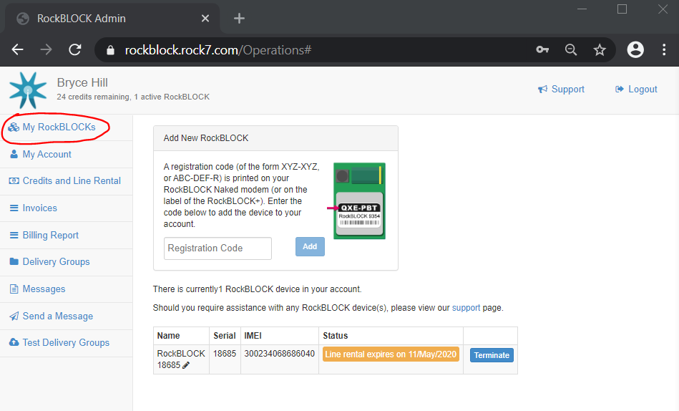

Under the “My Account” tab, you can find/edit the account information. For documentation purposes, a picture of the current information can be seen in the picture below.

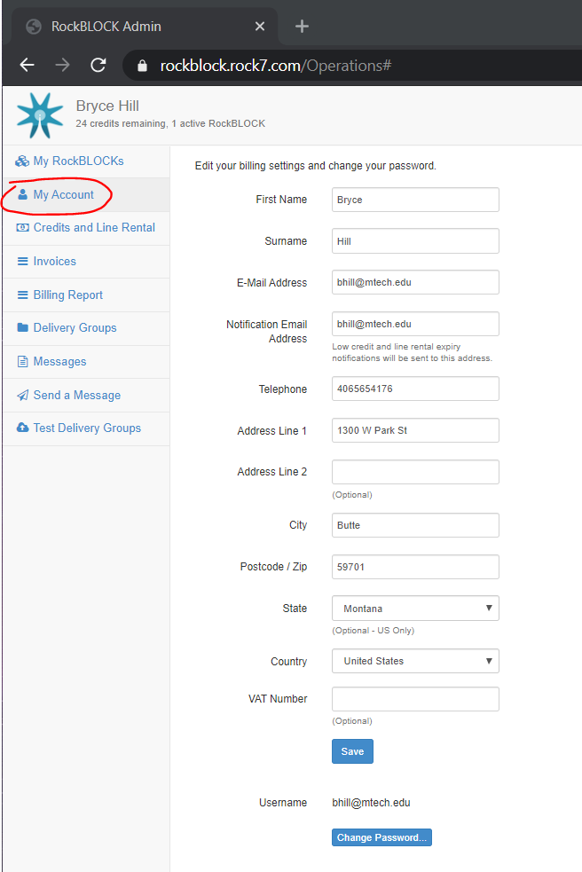

Under the “Credits and Line Rental” tab is where you need to go to purchase a line rental and message credits. Both the line rental and message credits are needed to send messages from the RockBLOCK. **1 message can have a maximum of 340 bytes, and every 50 bytes is 1 credit.** Notice, the currency is in Pounds. This still works with a US credit card, however **you will be charged a small fee along with the charge of the credits.**

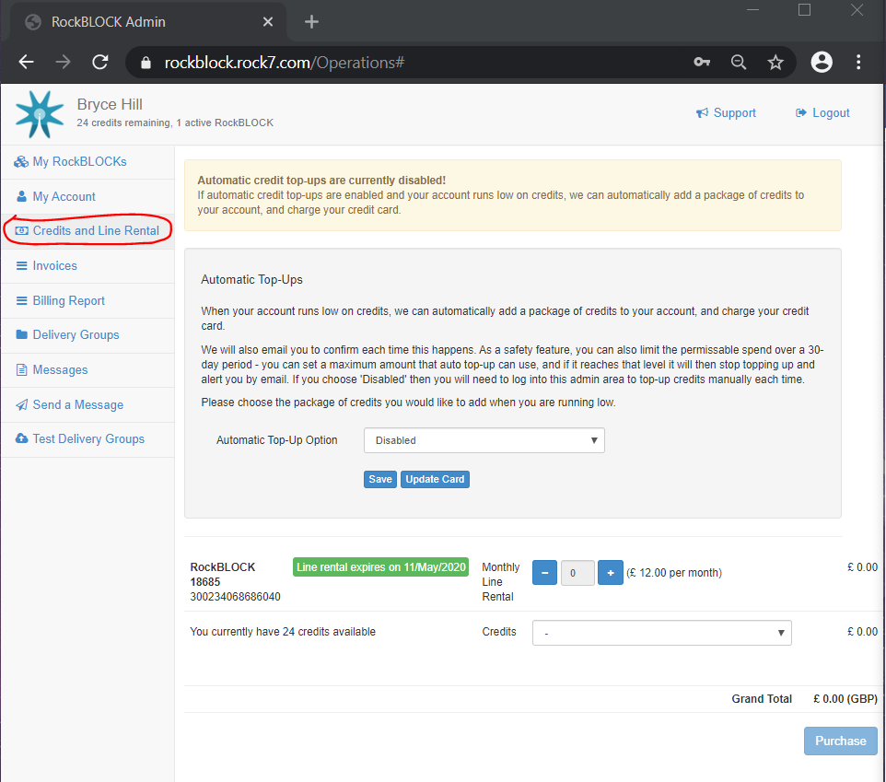

Under the “Invoices” tab, you can find a list of previous transactions linked to this account. The transactions can be looked at in more detail by clicking the blue “View” button under the “Actions” column of the invoice table.

The “Billing Report” tab is similar to the Invoices tab, but you can filter the search to see a transaction or transactions within a given time period.

The “Delivery Groups” tab is where you can find the setup for the message endpoint. As you can see, we currently have it set up to send to an email address. The email address(es) can be easily changed in the “Delivery Addresses” box.

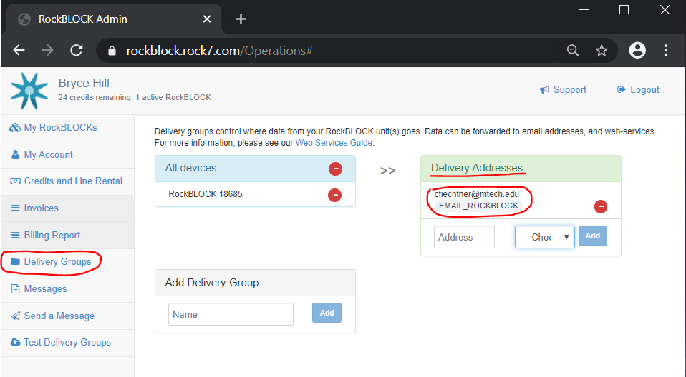

Under the “Messages” tab, you can filter a time period (similar to how the Billing Report tab works) to find messages sent within a given time period. If you click on the blue “View” Button on the very right of the message, it will bring up a window labeled “Message Details” where you can find more information including the contents of the message.

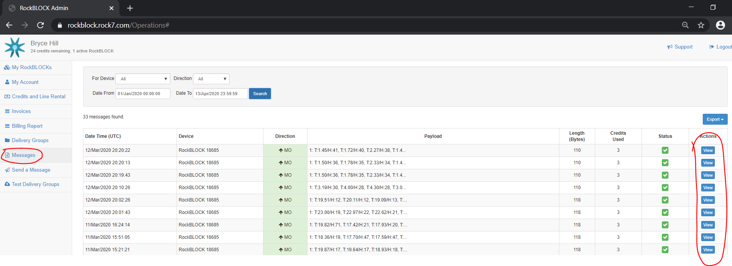

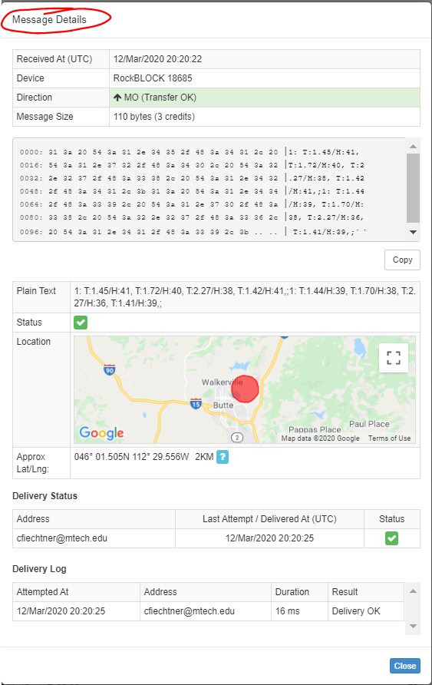

Under the “Send a Message” tab, you can apparently send a message **TO** the RockBLOCK. We have not found a use for this as of now, nor have we experimented with it. This is something you will have to figure out on your own if you see a potential use for it in the future.

Under the “Test Delivery Groups” tab, you can send a test message to your endpoint(s). We didn’t play around with this function very much either, but it seems straight forward to use.